Create the IBM Watson IOT Platform and a Device

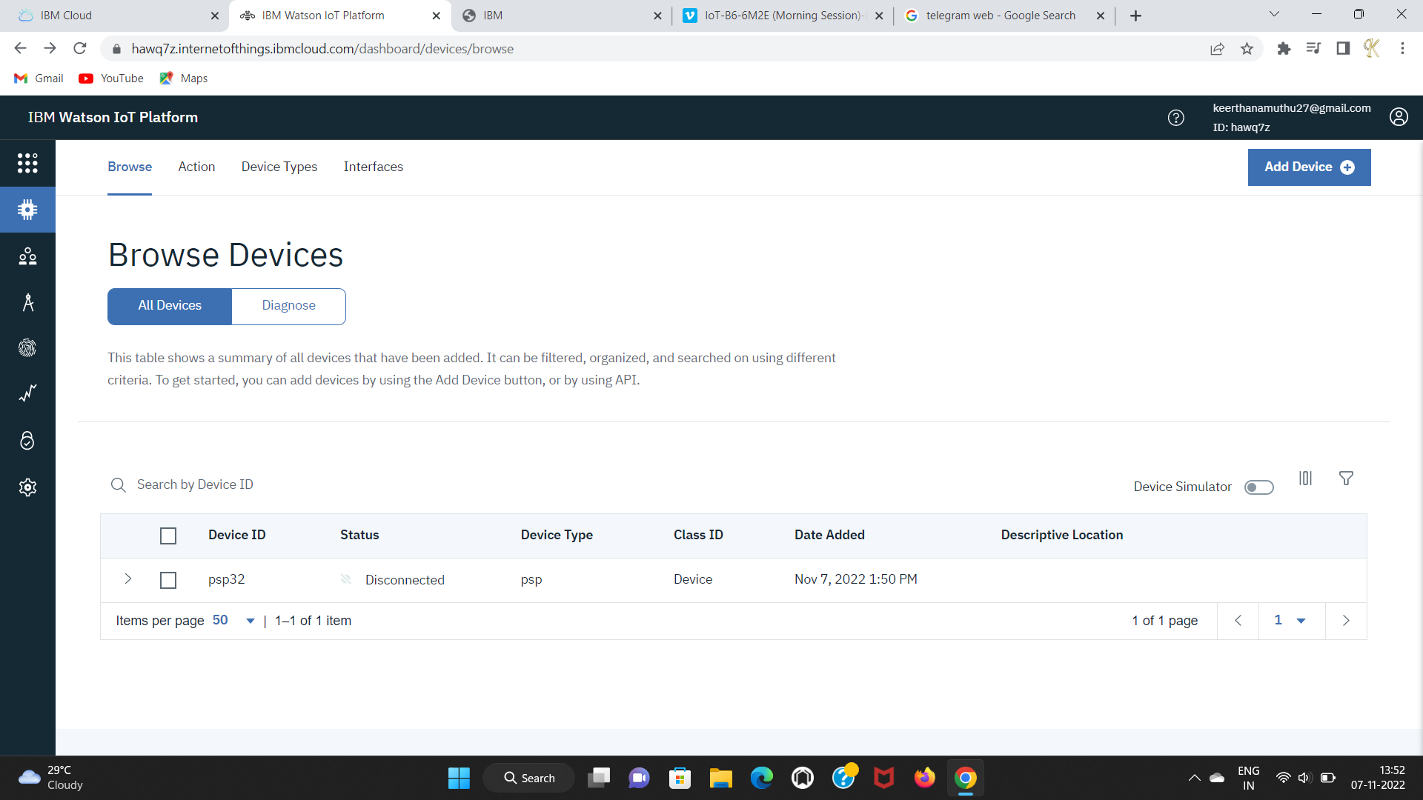

Develop a Mobile Application

